Exam – 1 – CSE 102

Part A: Multiple Choice Questions. [1*10=10]
- Each element of matrix is called
- dots (b) coordinate (c) pixels (d) value

- No of bits to store image is denoted by formula
- b = NxK (b) b = MxN (c) b = MxNxK (d) b = MxK

- Intensity levels in 8bit image are
- 255 (b) 256 (c) 244 (d) 245

- Negative of image is
- enhancing intensity levels
- reducing intensity levels
- adding intensity levels
- reversing intensity levels
- In bit plane slicing most of information of an image is contained by
- highest order plane (b) lowest order plane (c) mid order plane (d) all planes

- In bit plane slicing 8 bit image will have
- 6 planes (b) 7 planes (c) 8 planes (d) 9 planes

- Image can be blurred using
- low pass filter
- contouring
- erosion
- high pass filter
- Images usually gets corrupted during
- Transmission (b) degradation (c) restoration (d) acquisition

- For noise reduction we use
- image smoothing
- image contouring
- image enhancement
- image recognition
- Mean (average) filters reduce noise using
- sharpening (b) blurring (c) restoration (d) acquisition
Part B
[5 * 2 = 10]
- In order to obtain the image in Fig. 6.b) from the original image in Fig. 6.a), the following point processing operation should be applied:
a) contrast compression;
b) negativation;
c) histogram equalization;
d) histogram modification.

- On the original grey scale image from Fig. 7. a), which of the following point processing operations could have been applied to obtain the image in Fig. 7.b)?

a) Contrast compression;
b) Negativation (image inversion);
c) Some grey scale slicing operation;
d) Extraction of the most significant bit.

- Fig. 8.a) represents the grey level histogram of a digital image. After processing this image, one gets another grey level digital image with the grey level histogram shown in Fig. 8.b). What is the most plausible processing applied on the original image from the ones below?

a) Grey scale inversion (negative of the original image);
b) Binary thresholding;
c) Histogram equalization;
d) Some grey scale slicing.

14. The image in Fig. 12.a) is, most probable, obtained from:
a) The image in Fig. 12.b), after an edge detection
b) Subtracting, pixel by pixel, the image in Fig. 12.c) from the image in Fig. 12.b)
c) The segmentation through amplitude thresholding of the image in Fig. 12.b)
d) The image in Fig. 12.d), after an edge detection

15. How many different colors you can have in a 3 bit/pixel image ?
3 Bits means that the number goes from 000 to 111, which has 9 possible combinations. Including the RGB spectrum, the number of different colors would be (2^3)*3 = 24

Part C
[5*4=20 points ]

16. Consider the two 8-bit images in the following:

Each of these images has dimensions 20x20. Show the histograms of these images. Please note that the borders of the images shown in black are just to highlight the boundaries. The border is not a part of the image.
The histogram of the image on the left has a significant amount of whiteness in it, so the majority of the distribution would be clustered on the upper side. However, due to the black line going diagonally across the image, there would be some level of dark levels on the lower end of the historgram.
The histogram of the image on the right has extreme non uniformity, where the image is either black or white of what appears to be the same intensity. So the histogram would have two levels on opposite sides, one for black and one for white.

17. Apply appropriate filter to remove the noise from following figure [5]
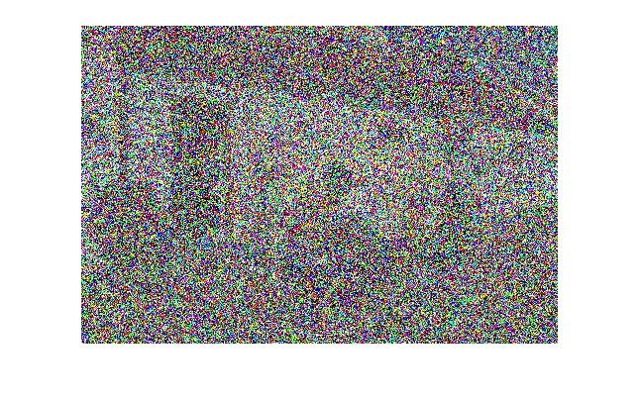

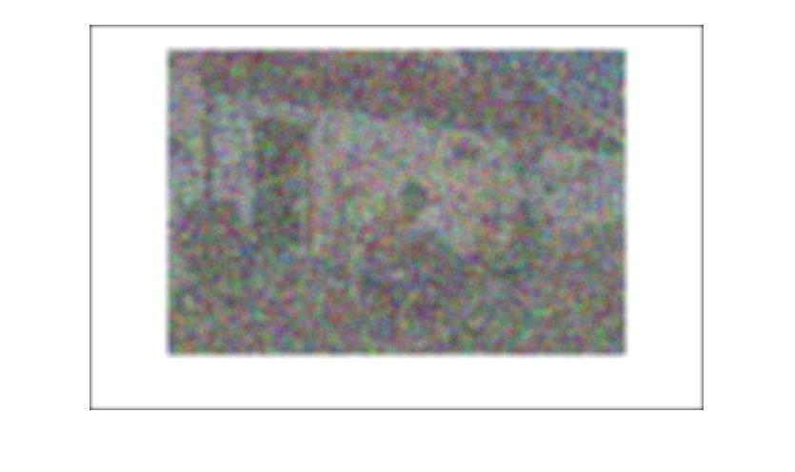

18. Show the following images with decreasing bits per pixel ( from 8 bit to 2 bit )

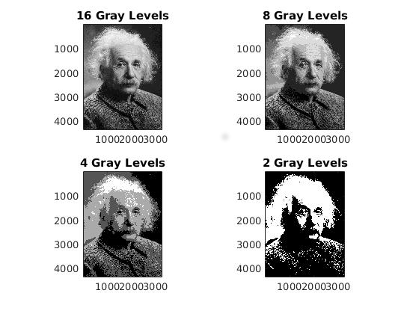
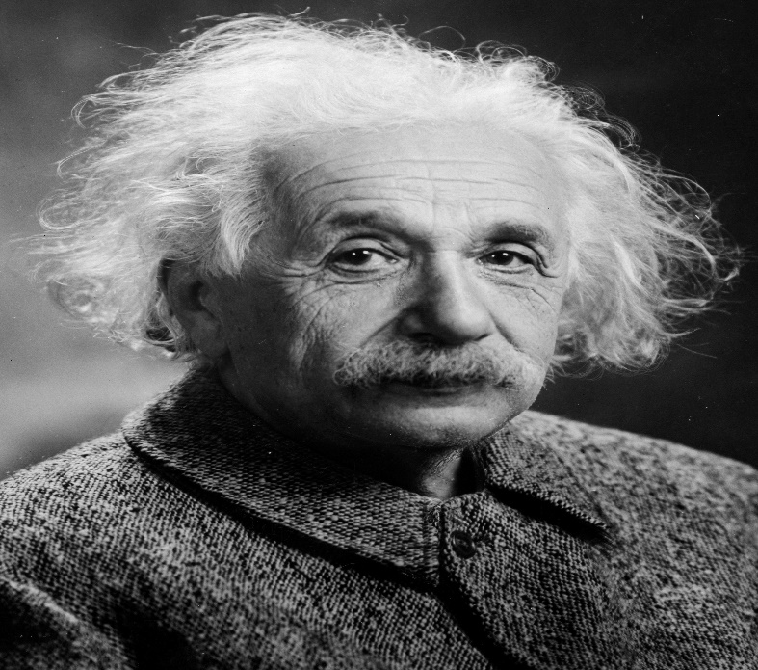

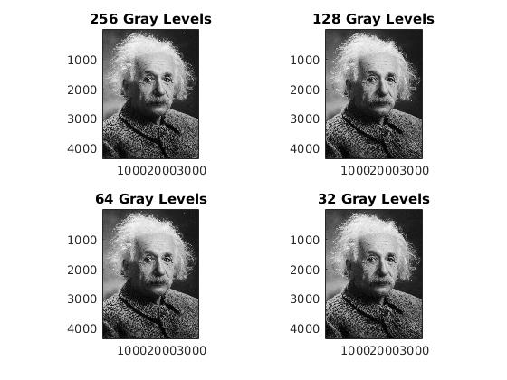

19. Apply ROI as monkey’s face and apply following filters.

(a) Average Filtering
(b) Unsharp Masking
(c) Laplacian Guassian

